input

'; show tables#

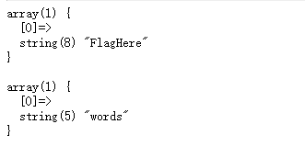

input

'; select \* from FlagHere##



filter select etc.

here use handler

input

1';handler FlagHere open;handler FlagHere read first;handler FlagHere close;

